**Gratitude to the Blessed One**

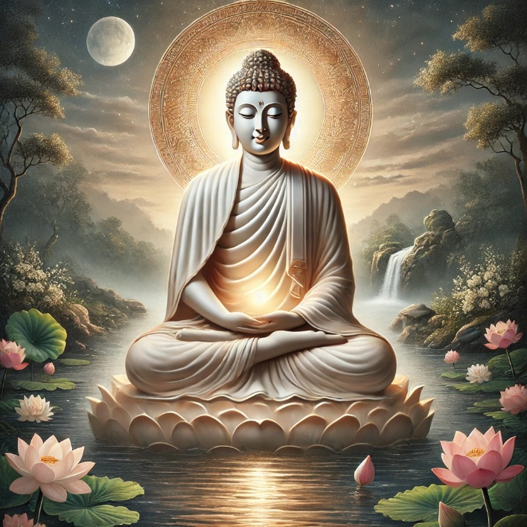

Image specially created by ChatGPT

With a heart full of reverence, we bow before you, O Blessed One, the incomparable Teacher, the Light of the world. Your boundless compassion, profound wisdom, and tireless service to humanity for forty-five years have illuminated the path of peace and liberation for countless beings.

Through your unshakable patience and unwavering kindness, you revealed the noble truth of suffering and the way beyond it. You showed us that ignorance can be dispelled, craving can be abandoned, and suffering can be transcended. You gave not only words but also the perfect example—living a life of purity, simplicity, and complete selflessness, asking for nothing in return.

Your Dhamma, like a cool stream, refreshes the weary and the lost, offering a refuge beyond all sorrow. Because of your compassionate effort, even now, over two and a half millennia later, your wisdom continues to guide those who seek the path of awakening.

We humbly express our deepest gratitude, O Fully Enlightened One, for your supreme gift to the world. May we strive to walk the path you so graciously showed, with faith, diligence, and an open heart.

Sadhu! Sadhu! Sadhu!